**PROTOCOL**to laboratory exercise

***Bode diagram simulation***

(v2)



|  |  |  |
| --- | --- | --- |
| Group / Class | Secretary | Signature |
| 5 / **3BHEL** | **HOFSTÄTTER A.** |  |
| Exercise- / Delivery date | Employee | Signature |
| 28. Nov. 2013  05. Dec. 2013 |  |  |
| Teacher | Employee | Signature |
| WAGNER |  |  |
| Grade | Employee | Signature |
|  |  |  |
| ***Device under Test***  ***RC low pass filter*** | | |
| **Used Programs**   |  |  |  | | --- | --- | --- | | Nr. | Name | Version | | 1. | **Altium Designer** | **13** | | 2. | **Micro Cap** | **11** | | | |

ÜBUNGS-/ABGABE-DATUM

Klasse /Gruppe

NOTE

LEHRER

# Contents

1 Contents 2

2 Tasks 3

2.1 RC low pass circuit 3

3 General calculations 3

3.1 Time constant $(τ)$ 3

3.2 Cut off frequency $(fg)$ 3

4 Simulation 1 (Altium Designer) 4

4.1 AC Small Signal Analyse 4

4.2 Analysis results 4

5 Simulation 2 (Micro Cap) 5

5.1 Ac Analysis 5

5.2 Analysis results 5

6 Simulation mistakes and errors 6

# Tasks

In this laboratory exercise a RC low-pass filter was simulated. The frequency behaviour was showed in a bode diagram for the ratio of ($\frac{Ua}{Ue}$). This bode diagram contains attenuation and phase shift.

## RC low pass circuit

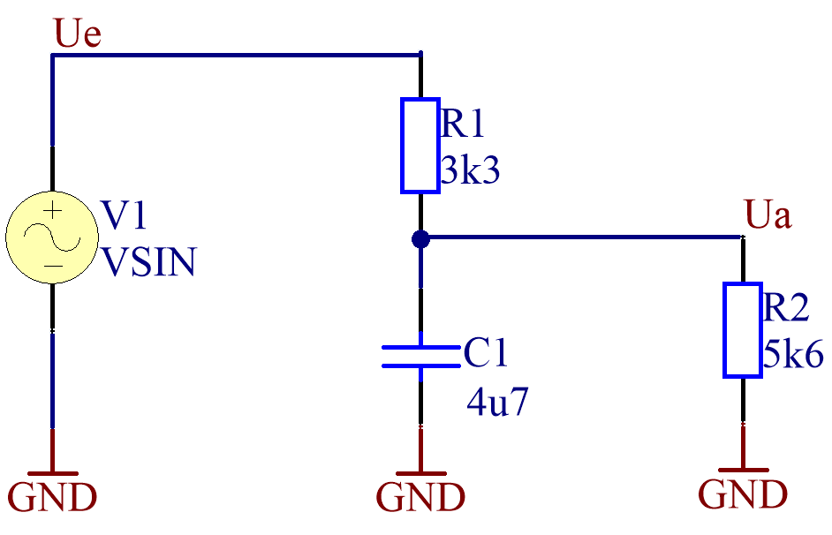

Figure 1 - low pass circuit

# **General calculations**

## Time constant $(τ)$

For optimal measure and representation of the bode diagram the time constant was calculated.

In this circuit the time constant is calculated as shown below.

$$τ=(R1//R2)*C1=(3.3 kΩ//5.6 kΩ)*4.7µF=2.076 kΩ*4.7µF →τ=9.759 ms$$

## Cut off frequency $(f_{c})$

With the time constant the cut off frequency could be calculated. This is those frequency in which the attenuation is 3dB lower than at low frequencys. At the cut off frequency the imaginary part of the complex resistance is equal to the real part, also a fact at this frequency is that the phase shift is exactly $-45°$.

$$f_{c}=\frac{1}{2*π*τ}=\frac{1}{2*π*9.759 ms}→f_{c}=16.31 Hz$$

# Simulation 1 (Altium Designer)

In the first case the circuit was simulated with an AC Small Signal Analyse in Altium Designer 2013.  
The settings of the analysis are shown below.

|  |  |
| --- | --- |
| Figure 2 - Analysis Setup | Figure 3 - Sine Generator Setup |

## AC Small Signal Analyse

For the frequency range a suitable area was chosen to see all scenarios. Based on the cut off frequency (16.31 Hz), which was calculated above, the area was chosen from 0.1 Hz to 100 kHz with 1,000 simulation points.

## Analysis results

Figure 4 - bode diagram of RC low pass (Altium Designer)

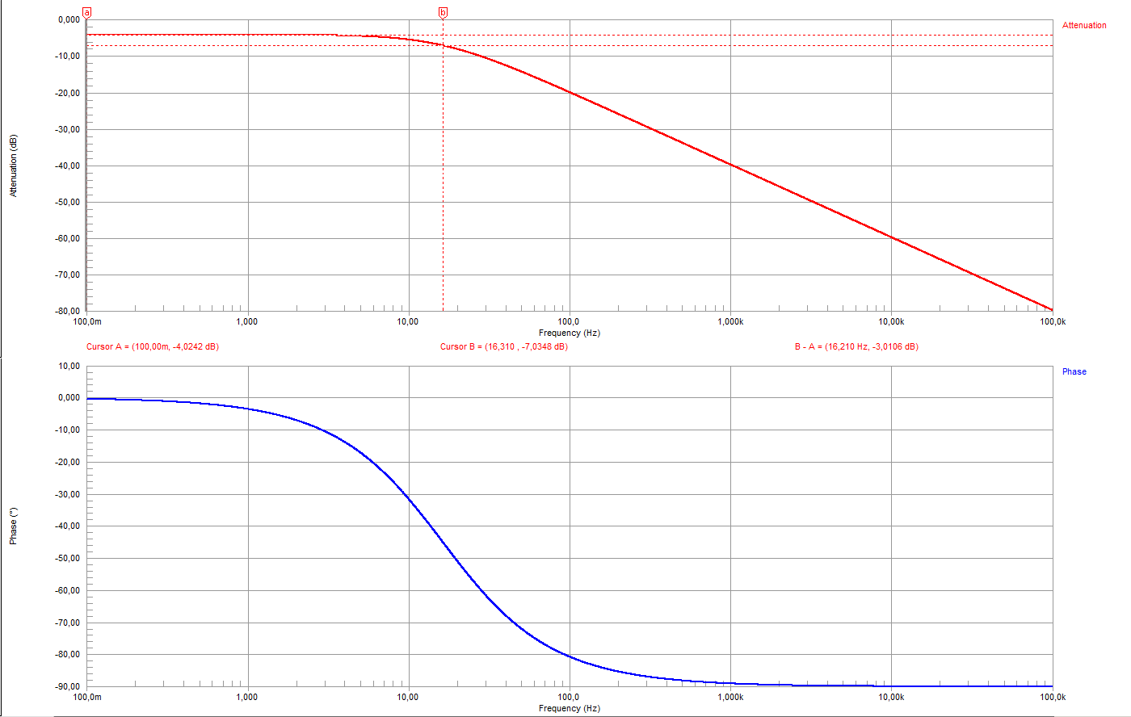

*fc = 16.31 Hz*

*fg = 16.31 Hz*

In the bode diagram which is shown on a decade logarithmic scale the attenuation and phase angel depending on the frequency can be seen.

In above bode diagram the attenuation at low frequency’s (in this case $<10 Hz$) is about 4dB. Based on the set cursors a and b the cut off frequency is shown. The attenuation there is about 3 dB lower as by low frequencies. After the cut off frequency the amplification goes downwards with -20 dB/Decade.

# Simulation 2 (Micro Cap)

To check the results of Altium Designer a second analysis was made. For second instance of simulating Micro Cap was used.

## AC Analysis

|  |  |
| --- | --- |
|  |  |
| Figure 5 - Circuit in Micro Cap | Figure 6 - Sine Generator Setup |
|  |  |

## Analysis results

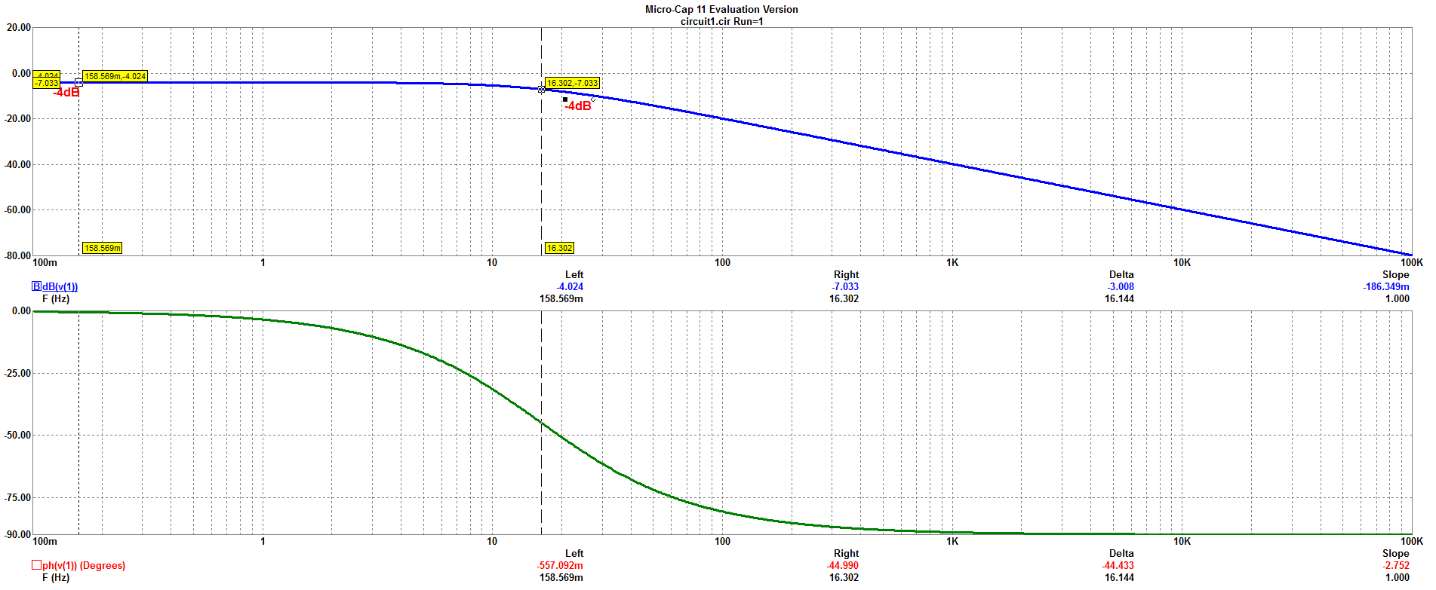

***fg*** = 16.30 Hz

-7dB

Figure 7 - bode diagram (Micro Cap)

Thereby everything was simulated correct both analysis came to the same results.

# Simulation mistakes and errors

In Altium Designer a very important thing is to define the component values properly.

For example: 3.3k – 3300 – 3.3e3 and not ~~3k3~~ → is recognized as 3k

4.7u – 4.7uF – 4.7e-6 and not ~~4u7~~ → is recognized as 4u

The biggest problem is that Altium Designer don´t give an error message. The wrong settings be taken without comment.

|  |  |
| --- | --- |
| Wrong Component Values | Right Component Values |
| Figure 8 - Wrong Component Values | Figure 9 - Right Component Values |

Wrong settings on these component values take effect on the whole analysis setup and all simulation results.

|  |  |  |
| --- | --- | --- |
|  | Wrong Settings | Right Settings |
| Measured cut off frequency | $$f_{g}=21.221 Hz$$ | $$f_{g}=16.31 Hz$$ |
| Attenuation at low frequency’s (0.1 Hz) | $$H\left(jω\right)=4.08 dB$$ | $$H\left(jω\right)=4.02 dB$$ |
| Attenuation at cut off frequency (16.31 Hz) | $$H\left(jω\right)=6.32 dB$$ | $$H\left(jω\right)=7.03 dB$$ |
| Phase shift at cut off frequency ($f_{g}$) | $$φ=-37.55 °$$ | $$φ=-45.00 °$$ |